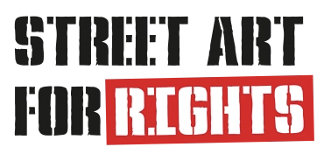

Street art for Rights Forum Festival:
An impressive 40-metre mural by
Dutch street artist JDL arrives in Rome

Street art for social issues lands in Europe
with a new three-year project that will also involve France and Greece

First stop in Corviale (Rome) where until 22 December the Dutch artist JDL will create a large 40-metre mural on the famous “Serpentone”

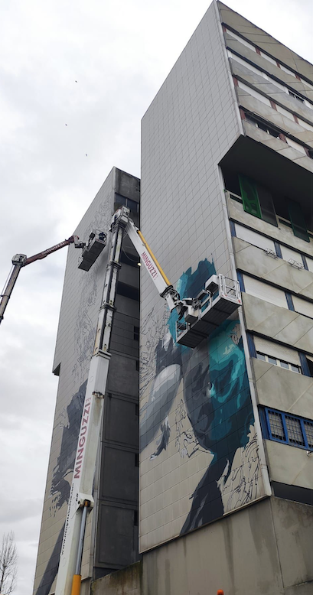

Street Art for Rights has increasingly established itself in recent years as a reference point for street art in Italy with over 30 wall murals realised in Rome in the suburbs of Corviale and Settecamini, creating two open-air museums, and in Lazio between Cassino, Fiumicino and Latina.
The greatest achievement, however, came this year with the recognition of the European Union under the Creative Europe Programme, which inaugurates a new three-year cycle of works and initiatives related to street art that will cross Italian borders to France, thanks to the association Pick Up Production, and Greece with the association Anazitites Theatrou.

The street art festival conceived and directed by Giuseppe Casa, curated by Oriana Rizzuto for MArteGallery and produced by the Cultural Association ARTmosfera was born as a special project of the MArteLive Biennial in 2014 and in these 8 years it has developed a shared path on the territory merging the promotion of important social values through urban art. This path now opens up to a European and international dimension that will hold many surprises in store.

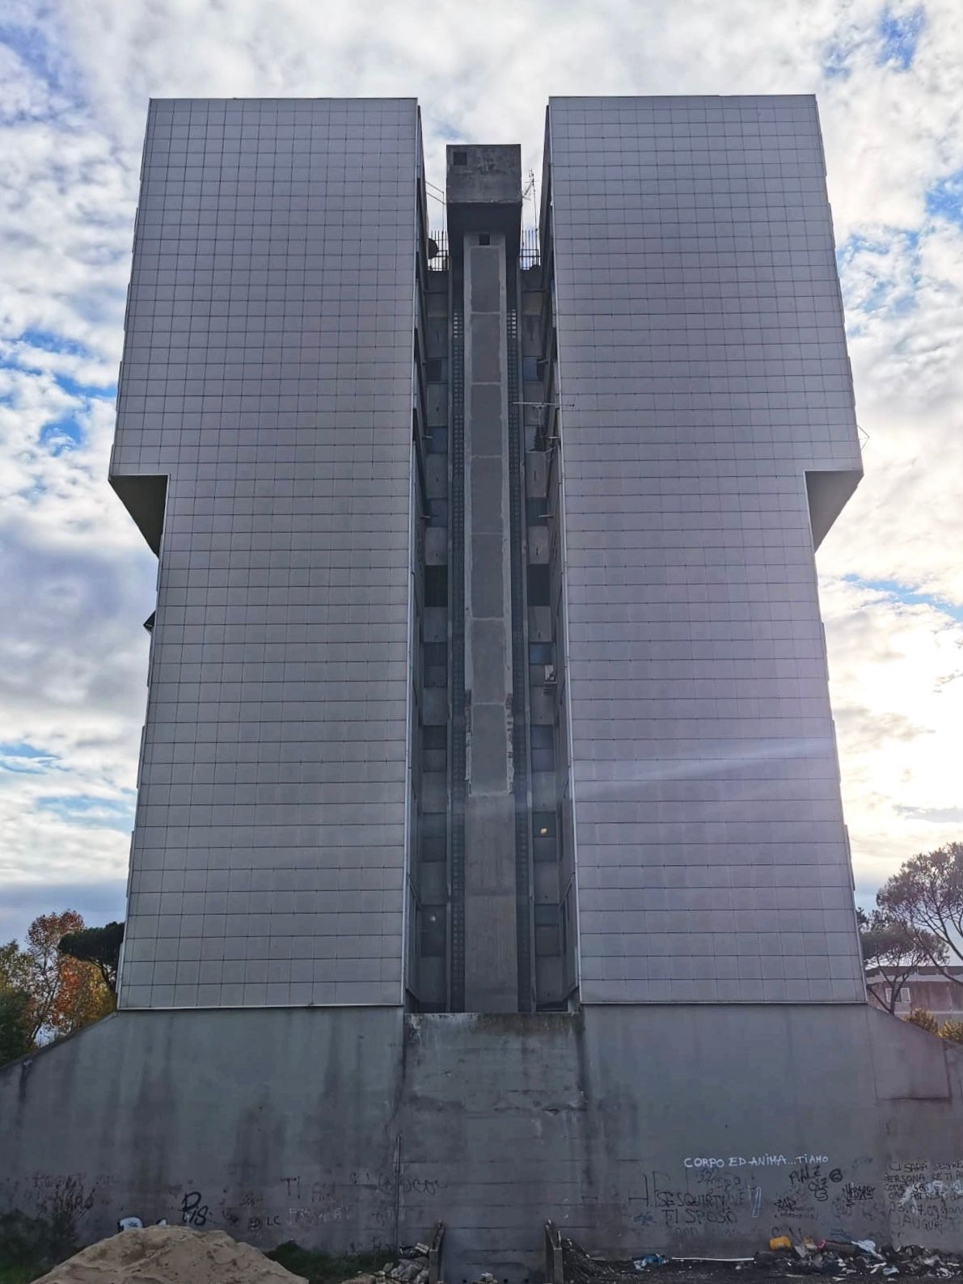
The first stage of the project is Italy - specifically in Corviale (Rome), a place where activities related to the project have already begun and which has repeatedly hosted initiatives and works by Street Art for Rights.

These days the grand finale will take place, starting with the Street Art for Rights Forum Festival project, which will offer a rich programme from 17 to 18 December. The most eagerly awaited event will be the unveiling on 22 December of the impressive 40-metre mural created by JDL on the north-east wall of the Serpentone, which is currently under construction.

In fact, until 22 December 2022 the well-known Dutch street artist JDL (Judith de Leeuw) will create an imposing 40-metre mural on the north-east wall of the Corviale building, the famous 'Serpentone'.
It will be a pharaonic work - perhaps one of the largest in the city - and will enjoy international visibility. No one has succeeded so far in creating a work on the Serpentone of Corviale, and it will be JDL who will succeed thanks to Street Art For Rights and the precious contribution of the MArteGallery team which in recent years has acted, through the MArteLive System, as an incubator for the project and as operational and creative support for its development.

With her style capable of translating emotions with realism and poetry, JDL has always been committed to spreading social messages through street art, working on issues such as LGBTQIA+, racism and mental health, recounting them on the walls of the world with care and lyricism, thanks to her unmistakable stroke.

The theme for the Corviale wall is an image of a woman covered in oil, similar to the birds caught in oil in the sea due to pollution and man's irresponsibility. On one side of the wall the woman will be portrayed struggling, on the other side she will find success, cleaning herself from the oil and flying. The image created by JDL takes its cue from the myth of Icarus: metaphorically, the climate crisis seems comparable to the original meaning of the mythological tale. Modern society is on a fatal and self-destructive path, just as Icarus did to escape from the Minotaur's labyrinth: heedless of his father's warnings, Icarus flew too high, causing the wax that held his wings together to melt and plummet into the sea.
JDL's work will have a temporary duration of about two years, as the Palazzone is affected by the renovation activities of the PNRR; during this time, however, before it is destroyed, it will be transformed into an NFT, so that it can continue to be visible and live online in the digital world of blockchain. Proceeds from the sale of the work will be donated to charity in the same neighbourhood.

JDL - specialised in large surfaces and important walls, with an artistic identity that is recognised and recognisable worldwide - is a brilliant young artist, active and known for her commitment to social issues and especially to women and the weak. Born and raised in Amsterdam, Judith de Leeuw started at the age of fifteen to create graffiti on the walls of the Dutch capital, achieving notoriety with the monumental mural dedicated to Amy Winehouse. Since then, JDL has become world-famous, working in dozens of different countries and garnering more and more success with her art, which has taken her from the streets of the Dutch capital to staggering prices.

Project realised thanks to the patronage of City Hall XI, the president Gianluca Lanzi and the council, the committees and neighbourhood associations, the partners Roma Best Practice and Mitreo Iside, the centre Nicoletta Campanella and the technical partners Minguzzi, Bricofer, Sikkens.

INFO:
www.streetartforrights.it
www.streetartforrights.eu
www.martegallery.it
www.martesocial.org
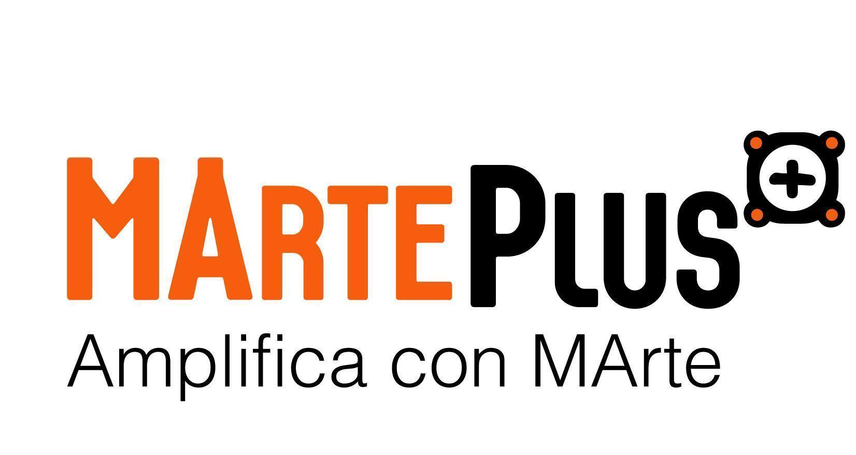

UFFICIOSTAMPA - MArtePlus - Agenzia di Comunicazione
Francesco Lo Brutto
Responsabile Marketing & Comunicazione
francesco.lobrutto@marteplus.it
+39 331.4332700

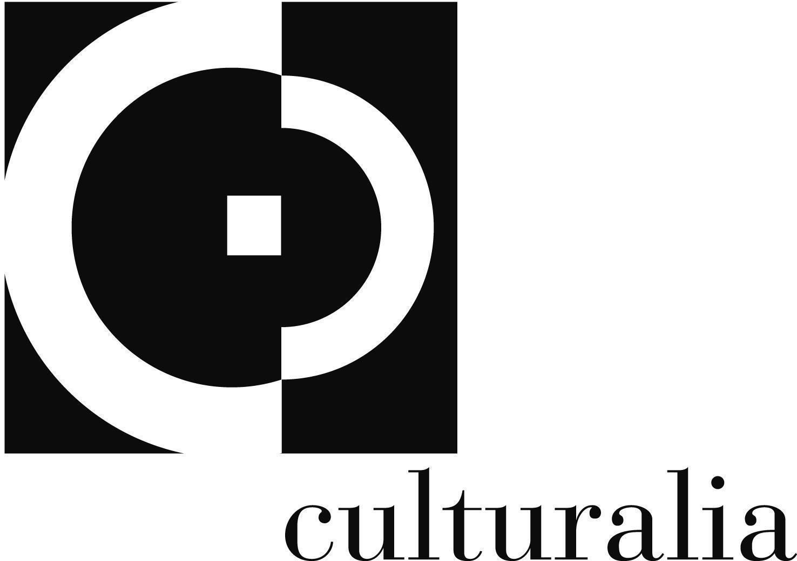

UFFICIO STAMPA ESTERO - Culturalia
Norma Waltmann
mob: +39-392-2527126
email: info@culturaliart.com

PARTNERS OF THE EUROPEAN PROJECT
Artmosfera (IT)
From 2007 to date, Artmosfera has contributed to the artistic direction, organization and logistics of the TolfArte Street Arts Festival, organized by the Tolfa Youth Community (RM) and has collaborated with the Roviano Youth Community (RM) with which Artmosfera organized numerous events in the area related to urban culture. In 2009, commissioned by the XV Municipality of the Municipality of Rome, Artmosfera organized the event for the presentation of candidacies for the Youth Council. In 2010, with the contribution of the Department of Cultural Policies of the Province of Rome, Artmosfera created the multi-disciplinary review ArteLive Project in the historic centers of Cerveteri, Carpineto Romano and Roviano. From 2012 to today, with the contribution of the Lazio Region, the project “Dialogue and artistic creativity” has been created, a path between art and intercultural that includes activities such as exhibitions, multidisciplinary events, competitions, workshops, publications. In 2015 Artmosfera organized the "Briciole di Rock" for victims of the Amatrice earthquake (charity event at the Planet Club in Rome).
Corviale Urban Lab: For 10 years, Artfmosfera has organized Corviale Urban Lab, a project born to implement a real involvement of the inhabitants of Corviale, district of Rome, in the cultural regeneration of their daily reality. The project has studied the territory, tried new ways of involvement and strengthened relations with the realities of the neighbourhood.
Street art for RIGHTS Italia: Artmosfera has been an institutional partner of “Street Art for RIGHTS Italia”, a 4-year artistic project focused on art realized in collaboration with the Cultural Association Mitreo Iside and the Cultural Association Ammuriliberi that has created a total of seven new works of street art on seven different walls respectively four in Cassino, one in Latina and one in Settecamini. During the implementation of the project, several open meetings and workshops have been organized involving local people to participate in different moments of discussion, at the beginning thought and programmed next to the creative local site, about themes connected to human rights and Sustainability.
Pick Up Production (FR)
Since 2017, Pick Up Production has been working on the issue of openness and hospitality, within the framework of the Transfert project, by organizing actions in the direction of the Roma and social centers of its territory. The association wishes to contribute to the reduction of inequalities and to reflect on innovative solutions to reduce discrimination. Its action wants to be reproducible to any type of organization and on any territory. Pick Up Production intends to work with professionals and organizations specialized in the targeted minorities, so that the proposals built are coherent with the realities of each. It wishes to feed itself in parallel with the initiatives already realized in this field. The competences of Pick Up Production are: Engineering of cultural projects and events; Artistic and cultural mediation; Artistic expertise in hip hop; Research.

Anazitites Theatrou (EL)
The most relevant projects by Anazitites Theatrou in connection with the StreetArt for RIGHTS proposal are:
Fix Small Art KA2 - examining different art methods and techniques supporting social tolerance practices and adult education for people with learning disabilities and mental illness, helping their social and personal empowerment enhancing the training skills of their teachers.
HEART4ART“Heart 4 Arts!” (H4A!): an international youth exchange in Thessaloniki. 46 young people from Greece, Cyprus, Croatia, Poland, FYROM and Romania, explained that human rights are violated everyday, everywhere.
3rd festival Select Respect. Anazitites theatrou is member of the network and one of the organisers. This is an informal network of organizations coming together in a common effort to combat discrimination based on gender, colour, racial background, sexual identity, religious and political beliefs.
The Cassandra Project ΦΙΞ residency // The Cassandra Project is an anti-disciplinary art project aimed at garnering conversation and deeper reflection around issues of gender based violence, sexual discrimination and social conditions that work to silence female and queer identifying bodies.
The project is realised with the contribution of the European Union within the framework of the Creative Europe Programme and the Città Metropolitana di Roma Capitale, under the patronage of the Municipio XI of Roma Capitale and in collaboration with MArteSocial, MArteGallery, Mitreo Contemporary Art Gallery, Brico Center, Sikkens, Roma Best Practices Award, Minguzzi SRL.

MArteGallery
The web breaks down barriers. Even the most resistant ones, among which are certainly those of art collecting, one of the worlds that has always been the most closed and inaccessible to most. But in the rampant process of democratisation or commercialisation that the web has set in motion, this has now also become an established reality.
More and more galleries are selling art online.
This is an interesting development for all those who have always wanted (or already do) to get hold of a piece by an established artist or a talent that could become one tomorrow.
MArteGallery is a virtual space dedicated to the exhibition of artistic works in any field (photography, painting, sculpture, graphics, etc.), the main objective being the dissemination of culture with the possibility of purchasing the works on display.
MArteGallery is the first 'art label' dedicated to emerging artists and galleries representing those already known
MArteGallery offers management and communication consulting as well as support, knowledge and tools for operating in the contemporary art world.
MArteSocial

MArteSocial is a new project of the Associazione Officine per lo Sviluppo Onlus in partnership with the Associazione Culturale Procult, which has been engaged for years in the organisation of cultural events such as MArteLive and has always had a strong social vocation inherent in its DNA.
MArteSocial is an incubator focused on solving social problems through artistic-cultural projects that can generate a positive impact on the inhabitants of less developed neighbourhoods that experience hardship and marginalisation.
Action springs from inspiration. MArteSocial stimulates the activation of young NEETs by offering opportunities to discover passions and talents. The young people involved are encouraged to exploit unexpressed potential and take their future into their own hands.
Through the activities and projects implemented, which touch on areas of considerable interest and curiosity for most of the young people in the age group involved, MArteSocial aims at:
- activating bottom-up projects, generated by the neighbourhood and with the activation of young people;
- attracting young people, identifying their goals and talents with the support of educators, tutors, psychologists and volunteers with previous experience in the sector, in customised, individual and collective motivational and in-depth paths;
- recognising, supporting and enhancing the often unexpressed skills and potential of NEETs in these areas;
- to inform and communicate on issues of importance for sustainable development, both at institutional level and to raise public awareness;
- bring NEETs out of their marginalised condition, activate their job placement and thus avoid falling into situations of social exclusion, in some cases combined with alcohol and drug abuse, up to and including involvement in organised crime;
- stimulate and incentivise each young person to take their future into their own hands.

